Computer Sci II Semester Project
Tiffany Thiessen
04/20/21

Retro Arcade

This semester I built a retro arcade featuring four working games including, Snake, Space Invaders, Pong, and a choose your own adventure game. It has a mostly working menu with an exit button. The resources I used were on YouTube or online article. I will include those links below. My inspiration for this project came from a desire to learn more about user interface and graphics, and a love of old games. This was an excellent project that pushed me beyond my previous levels of Java understanding and has been tremendously rewarding.
When I began with this project, I tried to make a high-level plan of what I wanted to accomplish. I knew I wanted to create multiple games, a selection menu, and working buttons to start the games and close the menus. I used Trello to plan the features of my project and attached any tutorials or resources I used to the cards that corresponds with the work. With the high-level plan in place, I tried to leave room for flexibility as I failed fast and learned better ways to program.
My goal was to have a working arcade, and for it to run seamlessly by the end of the semester. I didn’t quite hit the goal, but I have mostly functional menu screen, and four games that run seamlessly independent of the menu screen. My limitations were mostly due to time. Gaining the understanding needed to create this program from start to finish in one semester takes more time than I had. If I were to reassess this project and do the same thing again, I would probably plan to do two games and a menu screen to make sure I could accomplish that without major error first. I’m still very pleased with the outcome, and with a bit of extra time, I think I could have this program up and running to the caliber I want it to be.
With confidence, I can say that this project has been truly challenging. I’ve gained a love of programming this spring that I didn’t know I had. I’ve gained a ton of experience in problem solving. There were many times I had issues arise, and I had to find the answer for myself because others around me hadn’t encountered these issues in their own programming. Planning realistically for a minimum viable product is important to the development process and customer expectations, this has become quite apparent this semester. If I had promised a working arcade to my customer this semester, I may have disappointed them with my final working product; however, I believe overall that my project has been a success.

Trello Project Tracking
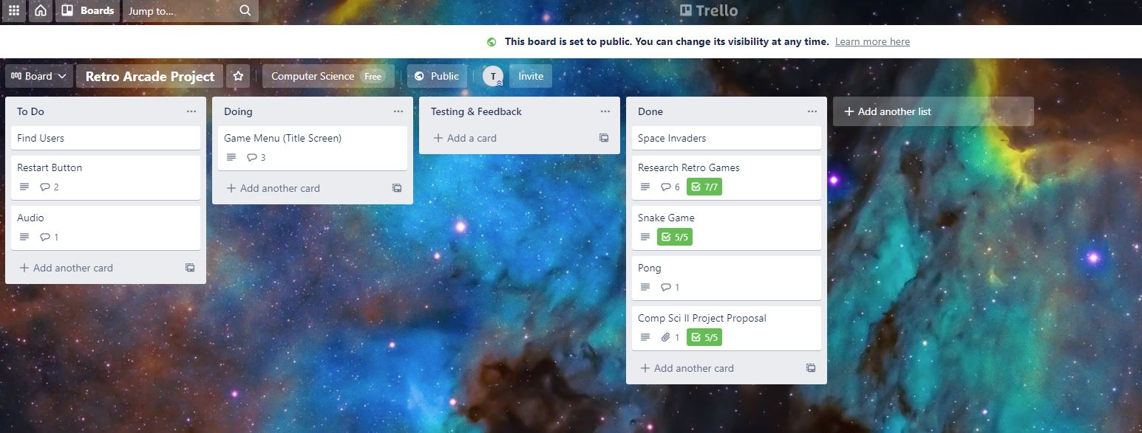
Resources and Links

Tiffany’s Trello Board: https://trello.com/b/MyuW6cs7/retro-arcade-project
Pong Tutorial: https://www.youtube.com/watch?v=oLirZqJFKPE
Snake Game: https://www.youtube.com/watch?v=bI6e6qjJ8JQ
Space Invaders ½: https://www.youtube.com/watch?v=0szmaHH1hno
Space Invaders 2/2: https://www.youtube.com/watch?v=dzcQgv9hqXI
Choose Your Own Adventure Game:
- https://www.youtube.com/watch?v=G5yr4sekAI0
- https://www.youtube.com/watch?v=RcvABhflOkI&t=0s
- https://www.youtube.com/watch?v=vUD5Mo2jjHs&t=0s
- https://www.youtube.com/watch?v=QTRaLkA-XBw&t=0s
- https://www.youtube.com/watch?v=LnDQTT3u0MQ&t=0s
- https://www.youtube.com/watch?v=AyB3LiF-XyA&t=0s

JavaFX Game Menu: https://www.youtube.com/watch?v=PTwpDkUMowk
JavaFX Game Menu New Scene on Click Button: https://stackoverflow.com/questions/42841930/javafx-new-scene-on-button-click

Retro Arcade Code

GitHub tiffanyt13: https://github.com/tiffanyt13/Computer-Sc-II/tree/master/RetroArcade
Space Invaders Game Independent Code: https://github.com/tiffanyt13/Computer-Sc-II/tree/master/Space
Snake Game Independent Code: https://github.com/tiffanyt13/Computer-Sc-II/tree/master/Snake
Adventure Game Independent Code: https://github.com/tiffanyt13/Computer-Sc-II/tree/master/Adventure

